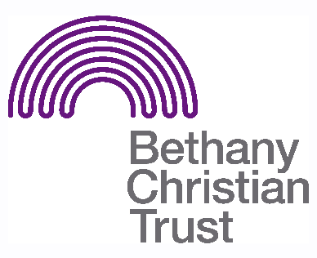

Title: Men’s Group Volunteer
Basis: Volunteer
Safeguarding: No PVG checks necessary. There is a minimum age limit of 18 for volunteers at this group.

Responsible to: Passing the Baton staff
Responsible for: Helping with the running of the Men’s Group

Summary of the role:
The Men’s Group is a place for friendship, support and encouragement. Volunteers are required to help facilitate this in a variety of ways.

General responsibilities:

- Help set up the hall for use during the group, and prepare food and drinks. After the group has finished, the volunteer is also expected to assist in cleaning and housekeeping. For this reason, a volunteer should arrive on time and give as much notice as possible if they are unable to volunteer.
- Help make the individuals attending the group to feel welcomed and comfortable. This can be through serving food and drinks, facilitating activities or having a chat. The volunteer should balance this with being aware of boundaries.
- At times, and where appropriate, a volunteer may need to take the lead on preparing and/or supervising an activity, though always with the supervision and support of the Bethany Christian Trust staff. Volunteers are encouraged to use their knowledge and skills to support Bethany staff to create an activities programme.
- Help to facilitate and organise trips (if there is a desire to do so).
- Signpost individuals who are seeking support to staff.
- Alert a staff member in the group if you have concerns about an individual or situation within the group
- We work in an asset based way so we would encourage our volunteers to work in this way and help towards co-producing the program.

Important pre-requisites for the role:

- Having a particular skill or talent (e.g. playing the guitar) can be really useful.
- Ideally, a volunteer would have experience of working with individuals with mental health issues and/or addiction issues.
- The volunteer would need to be reliable and willing to commit to building stable connections with members of the group.
- The role can be challenging, and so the volunteer must be patient, understanding and willing to be proactive in engendering a positive environment.
- Though the role does not require the volunteer to be a Christian, they must be aware and respectful of the Christian ethos upon which Bethany Christian Trust is founded.

Location
- Capital City Church, 107c McDonald Rd, EH7 4NW

Pattern of hours
- The group runs on a Thursday morning/lunchtime. Exact timings to be discussed.

Training and support Available
- All Volunteers will receive the necessary training as appropriate.

Last updated: August 2023

